Editing Event Codes to Account for High and Low Anxiety Participants

a. Navigate to the PsychoPy results Excel file for the participant in the “PMA PsychoPy Results” folder.

b. Click on the second sheet tab (Sheet1). The first cell of the sheet will tell you if the participant is high anxiety or low anxiety

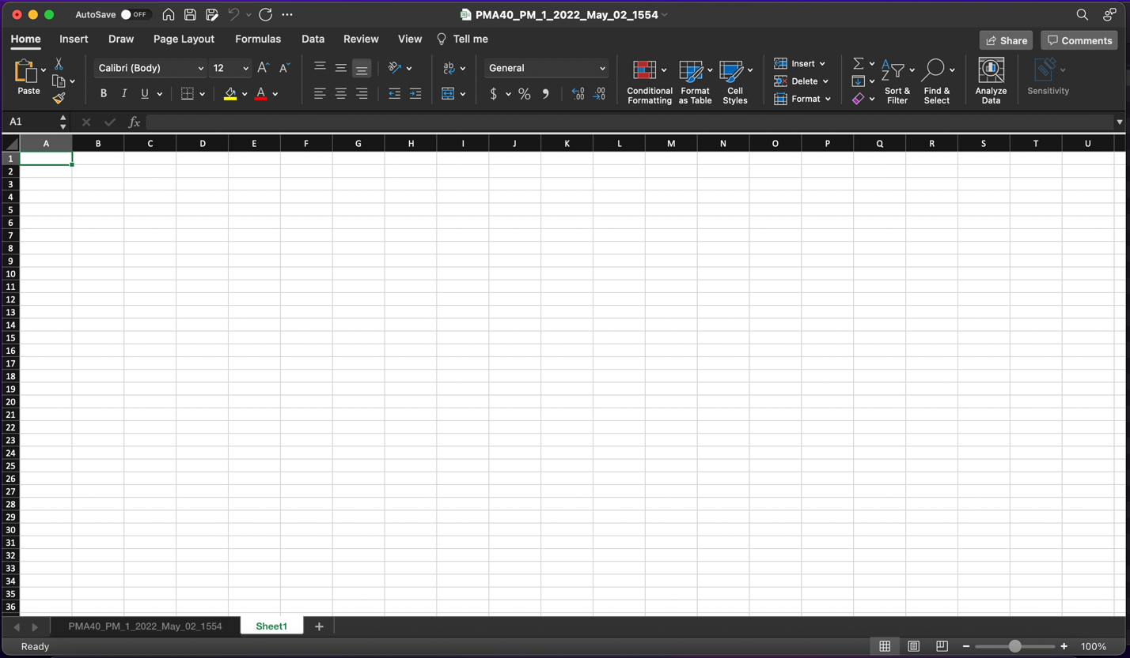

high anxiety

In the excel sheet with the results, copy the “trial”, “cue”, “stimulus”, and “response” columns. Paste these columns into the new sheet tab, leaving a few rows open above the variables.

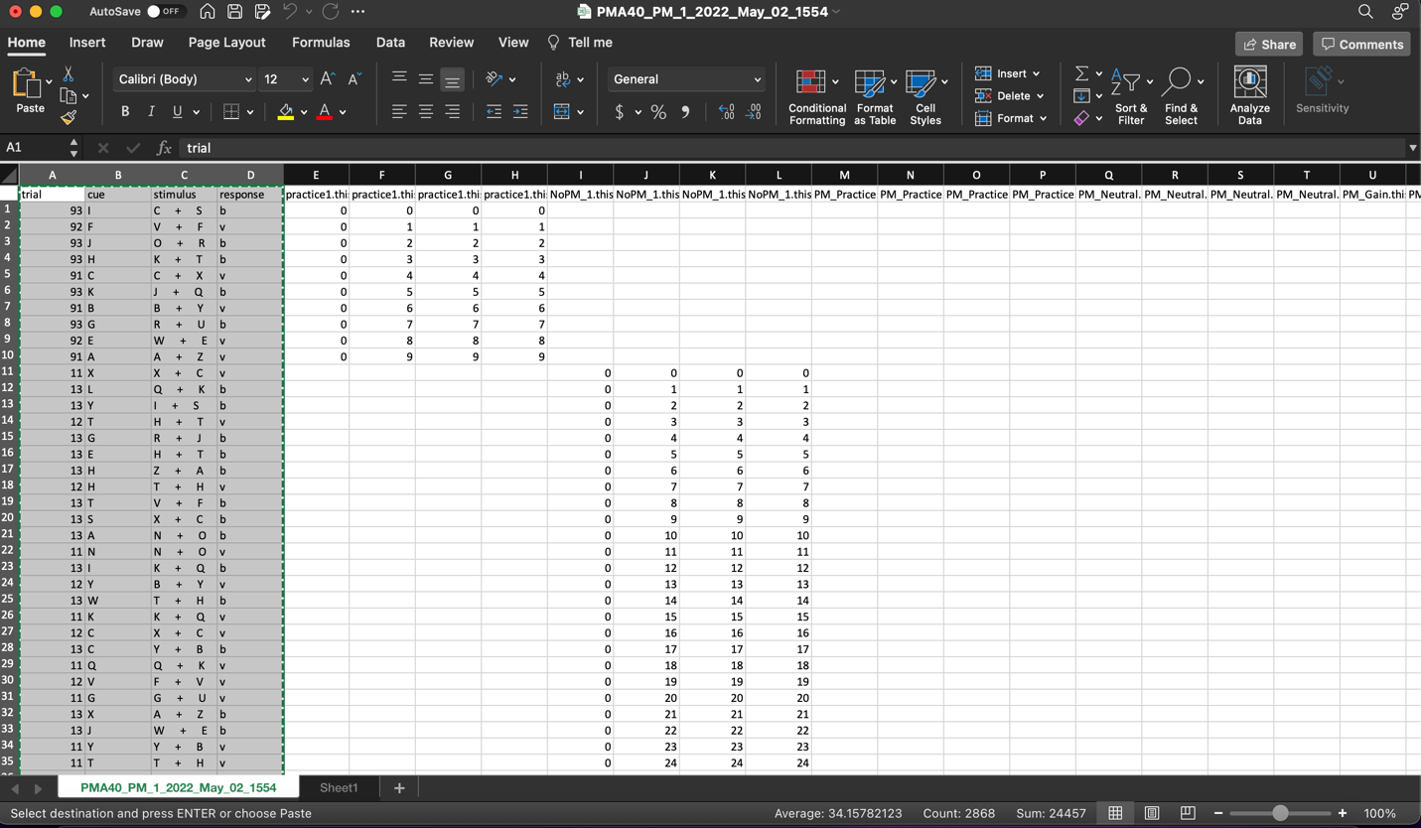

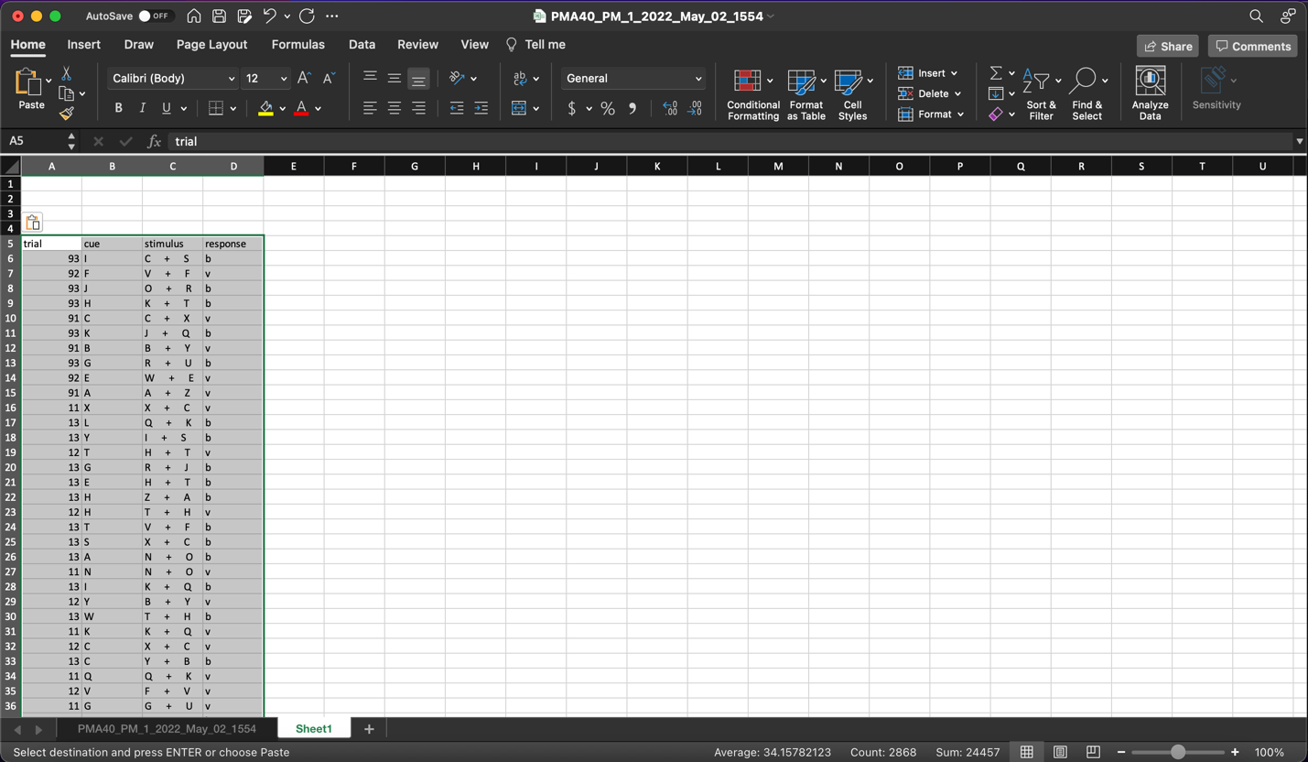

high anxiety

In the excel sheet with the results, copy the “key_resp_3.key” and “key_resp_3.corr” columns. Paste these columns into the new sheet tab

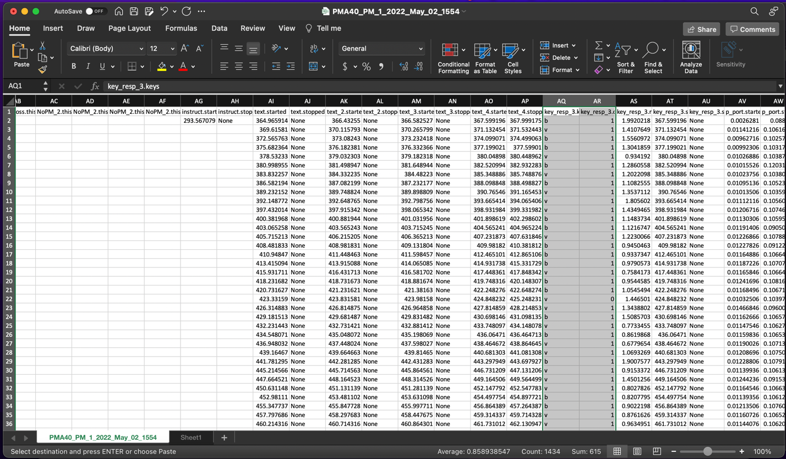

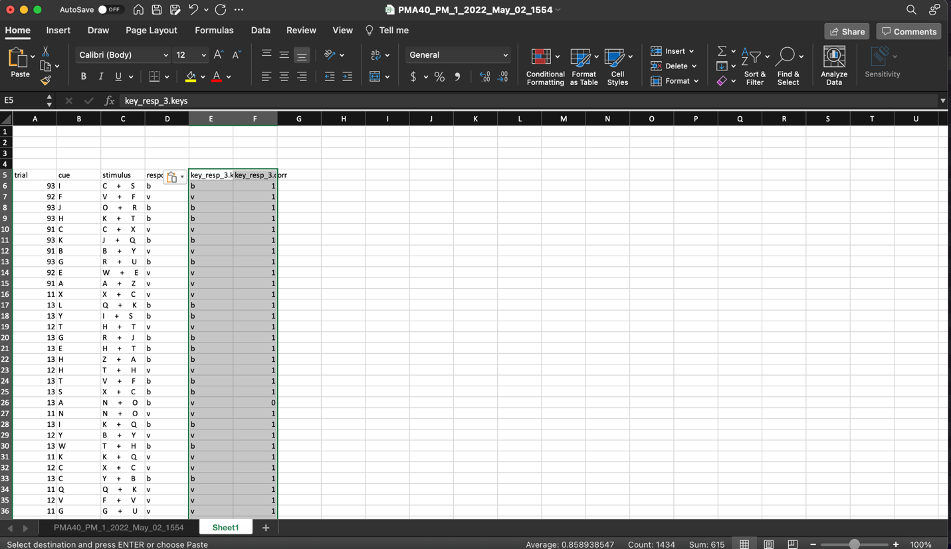

high anxiety

c. In the next column over, type “=”. Select the value in the “trial” column, type “*”, and select the value in the “key_resp_3.corr” column. Hit enter. Click on the corner of the cell with the formula you just created, and drag down to insert the formula into the cells for every trial.

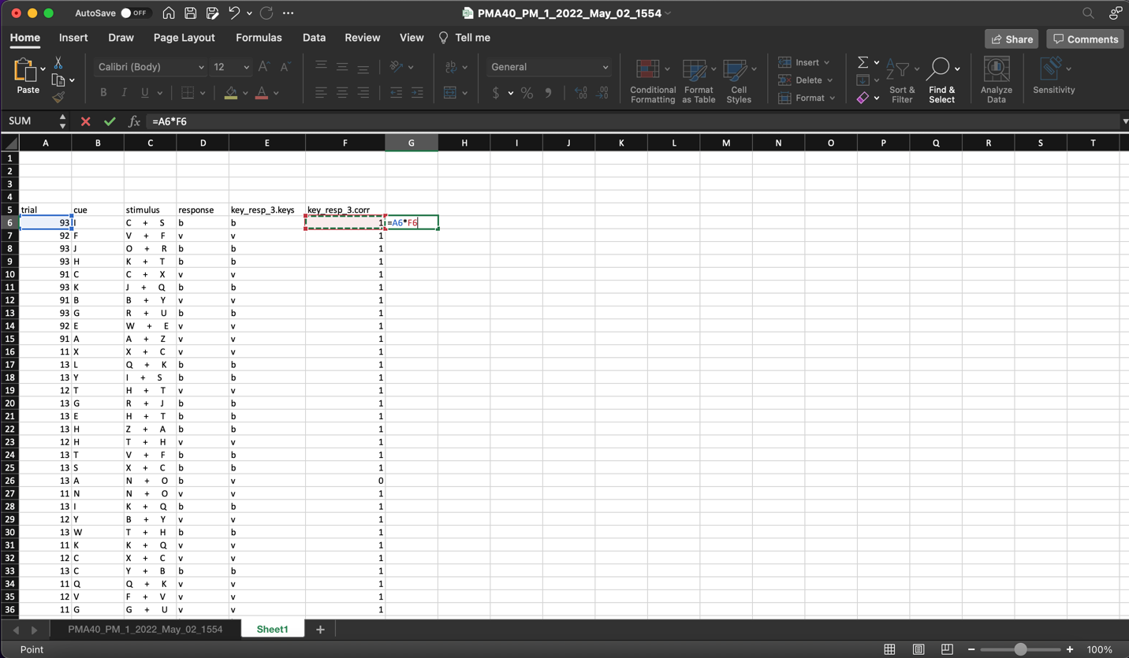

high anxiety

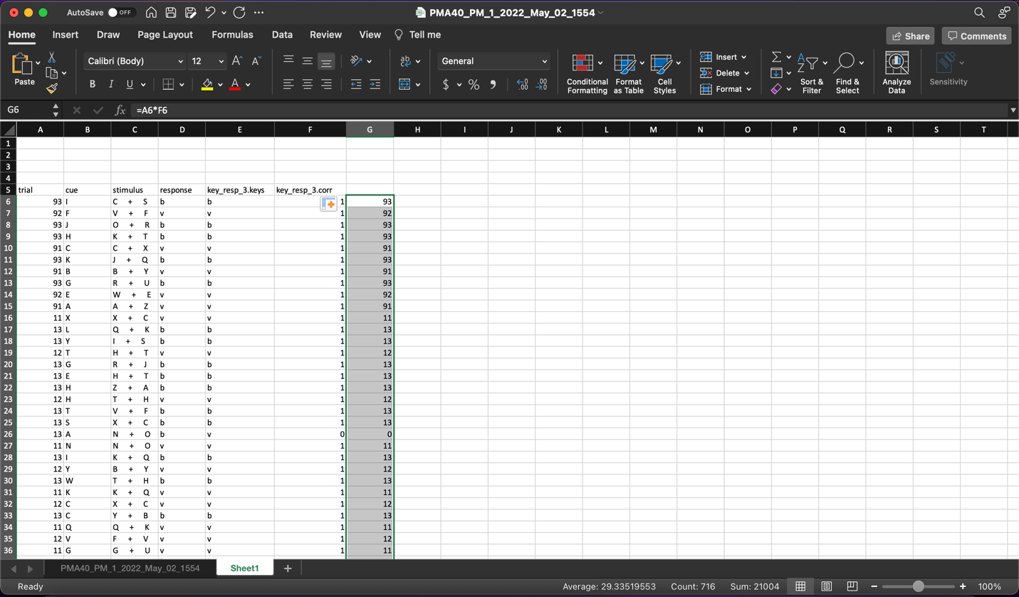

high anxiety

Copy the column with the formulas. Right click in the next column over and select “Paste Special”>Values

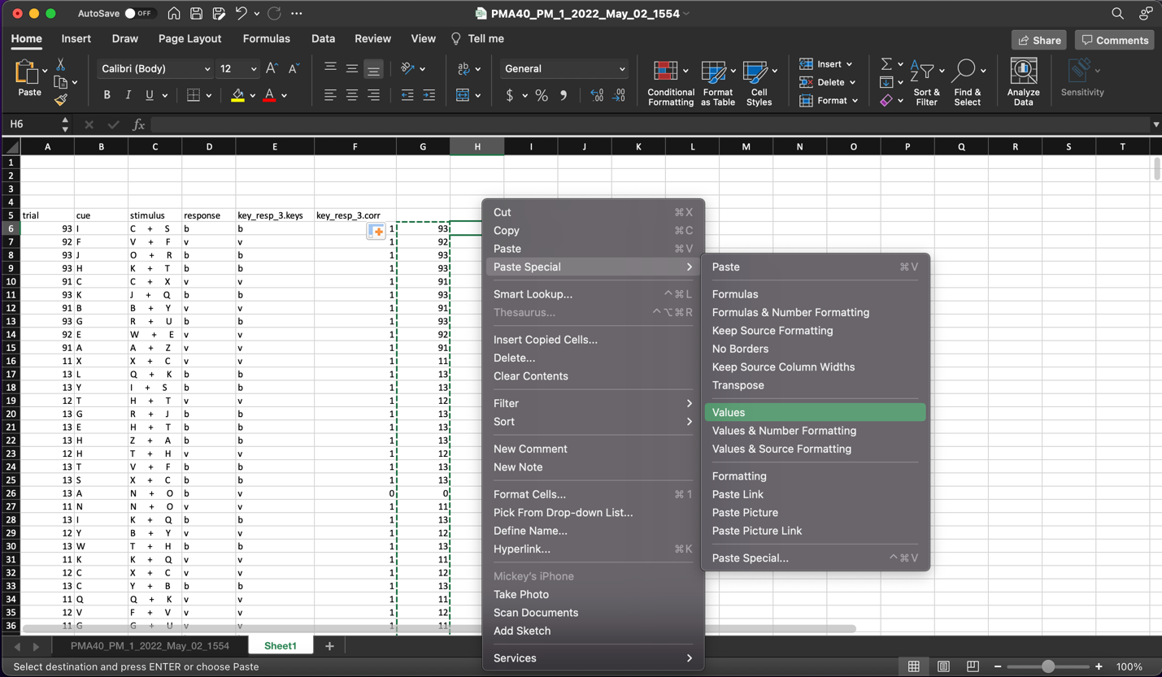

high anxiety

e. Highlight the column you created with the new values. Press ctrl + H on the keyboard. In the Find What box, type 0. In the Replace with box, type 999. Select Replace All. You have now indicated which trials were answered incorrectly during the task.

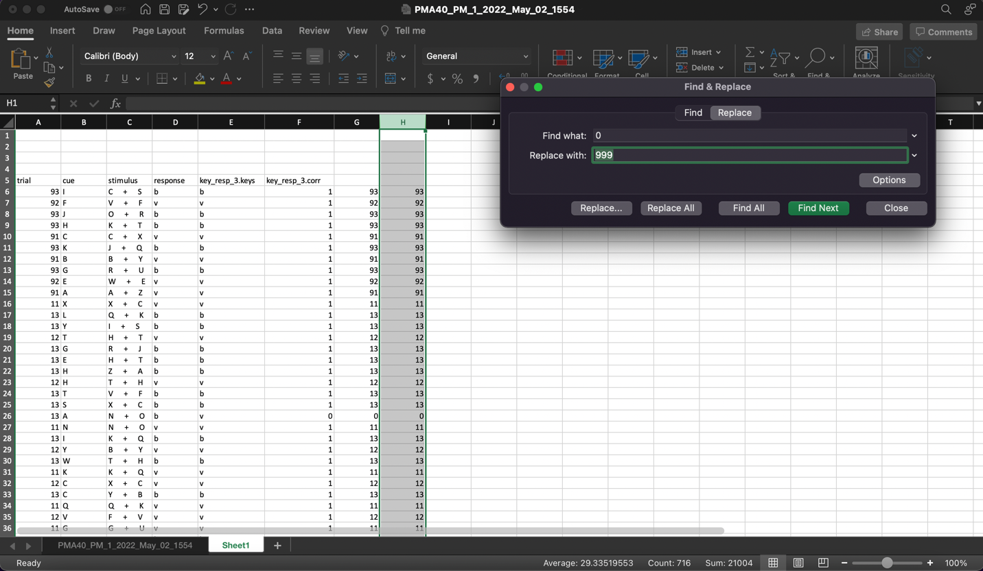

high anxiety

e. Go back to MATLAB. Copy the “code” column. 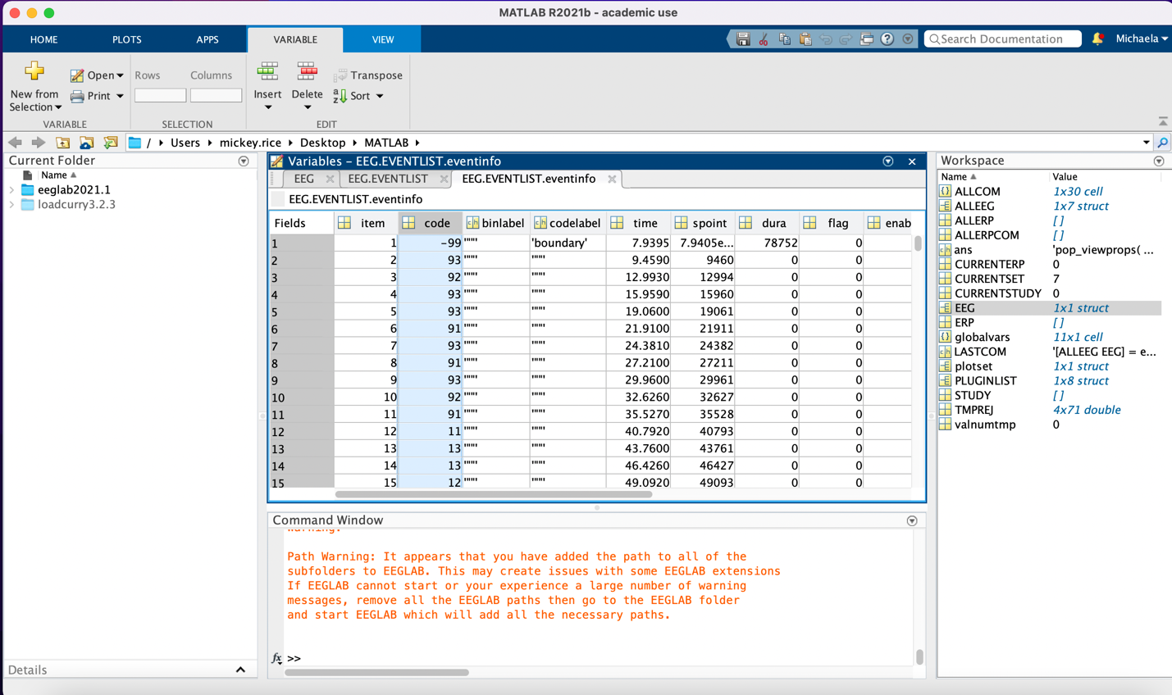

Paste this column into the next available column in the Excel sheet. Title this column “FROM MATLAB”.

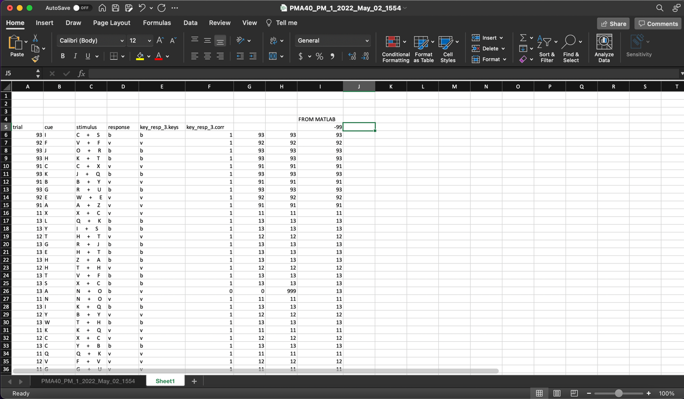

high anxiety

f. Press ctrl + F and type -99. Press enter to find every -99 value in the “FROM MATLAB” column. This value denotes that a section of data has been deleted and replaced with a boundary, which is what you did in step 5 when you removed bad segments of data.

When you find a -99 value, select the cell immediately to the left. Right click on the cell and select insert>select Shift cells down>select Ok. In the new cell, type -99.

When you are finished, the “FROM MATLAB” column and column to the left of it should be the same length. If they are not the same length, you need to scroll through the data to see where there is an issue. There values in these two columns should be the same, except for the addition of 999 values in the second to last column.

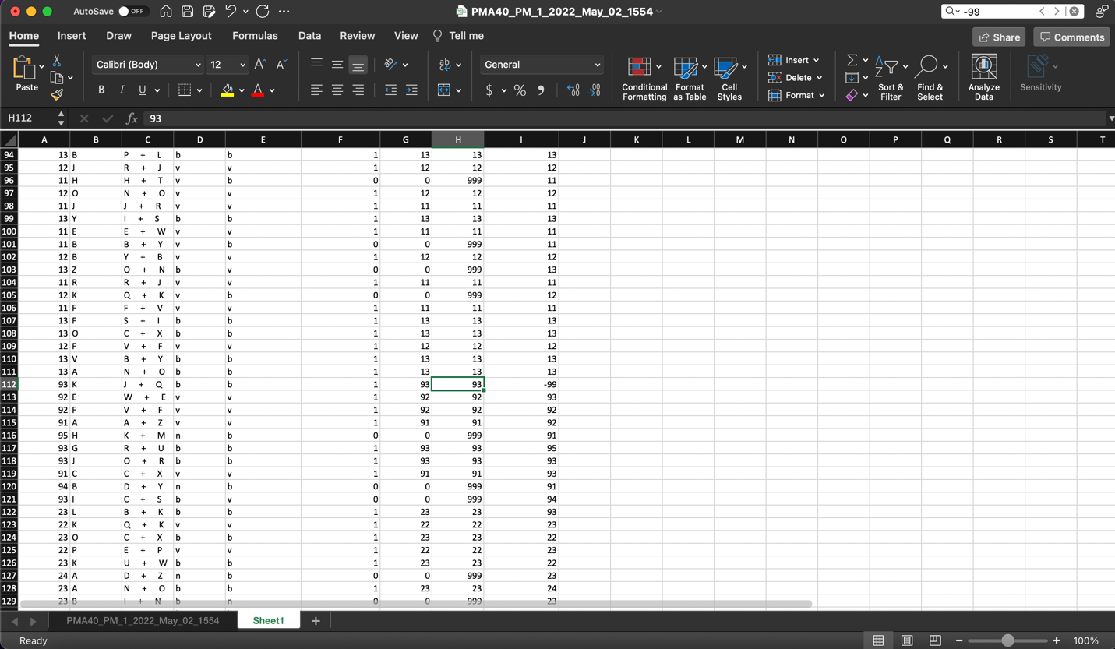

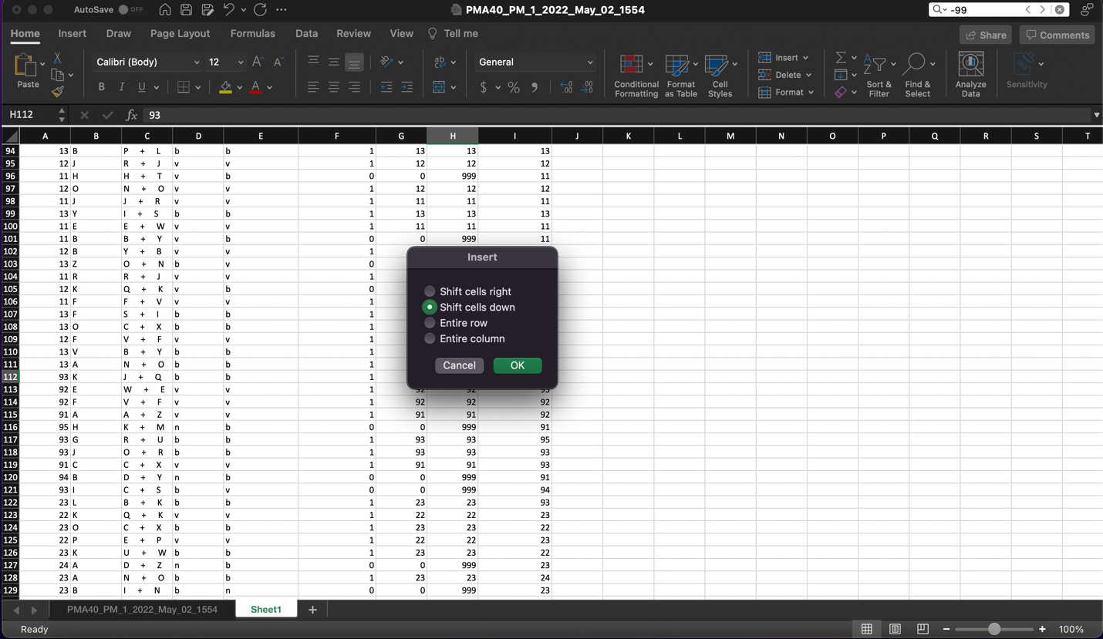

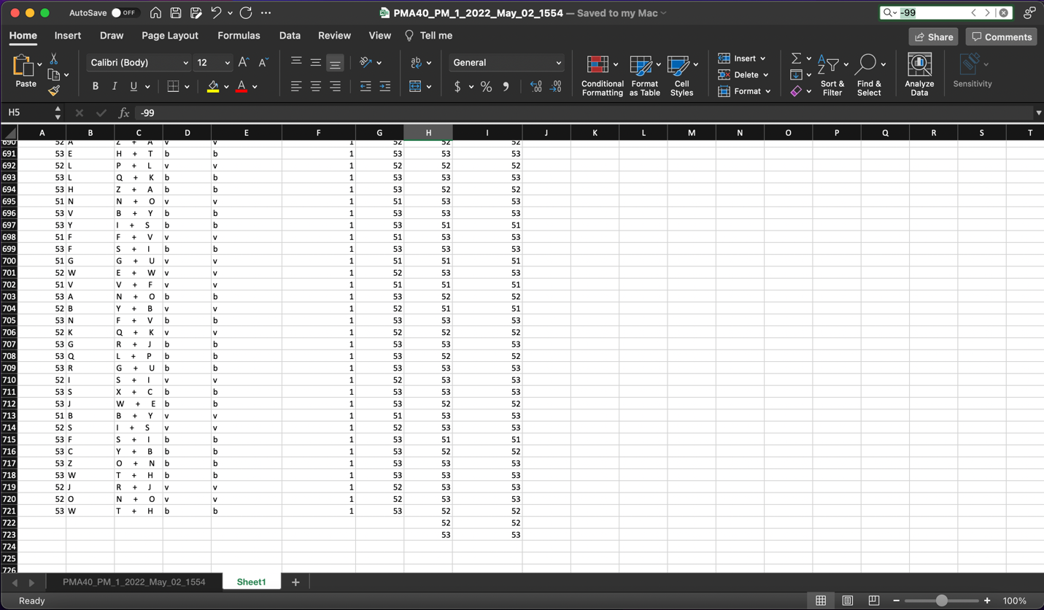

**If the participant is high anxiety, you are done, and you may perform the following steps:** Scroll to the top of the sheet and name the column you have just edited “CORRECT CODES”.

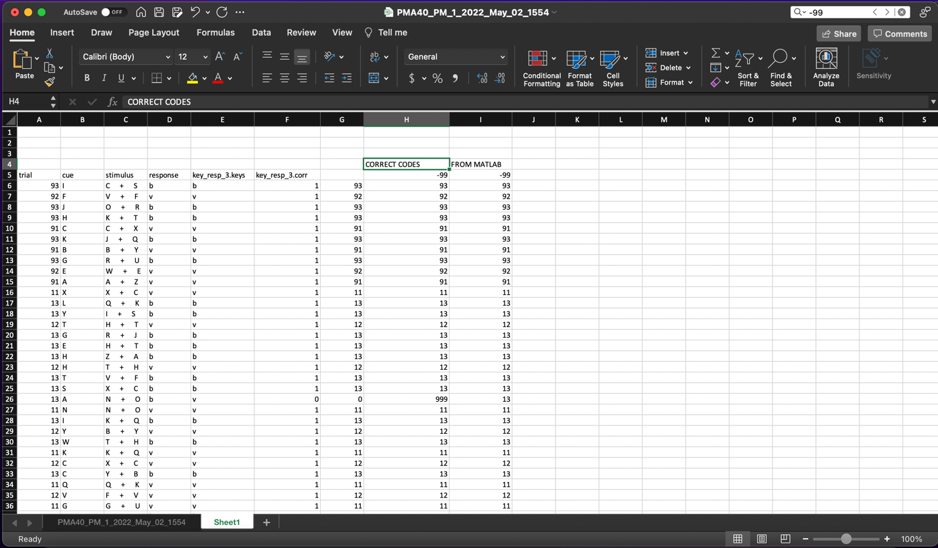

high anxiety

**If the participant is low anxiety, you have more steps to complete before you can title anything “CORRECT CODES!**

**STEPS G – I ARE FOR LOW ANXIETY PARTICIPANTS ONLY. SKIP THESE STEPS FOR HIGH ANXIETY PARTICIPANTS.**

g. Type 100 into the cell to the right of the “FROM MATLAB” column. Drag this cell down so there is a column of 100s that is the same length as the “FROM MATLAB” column.

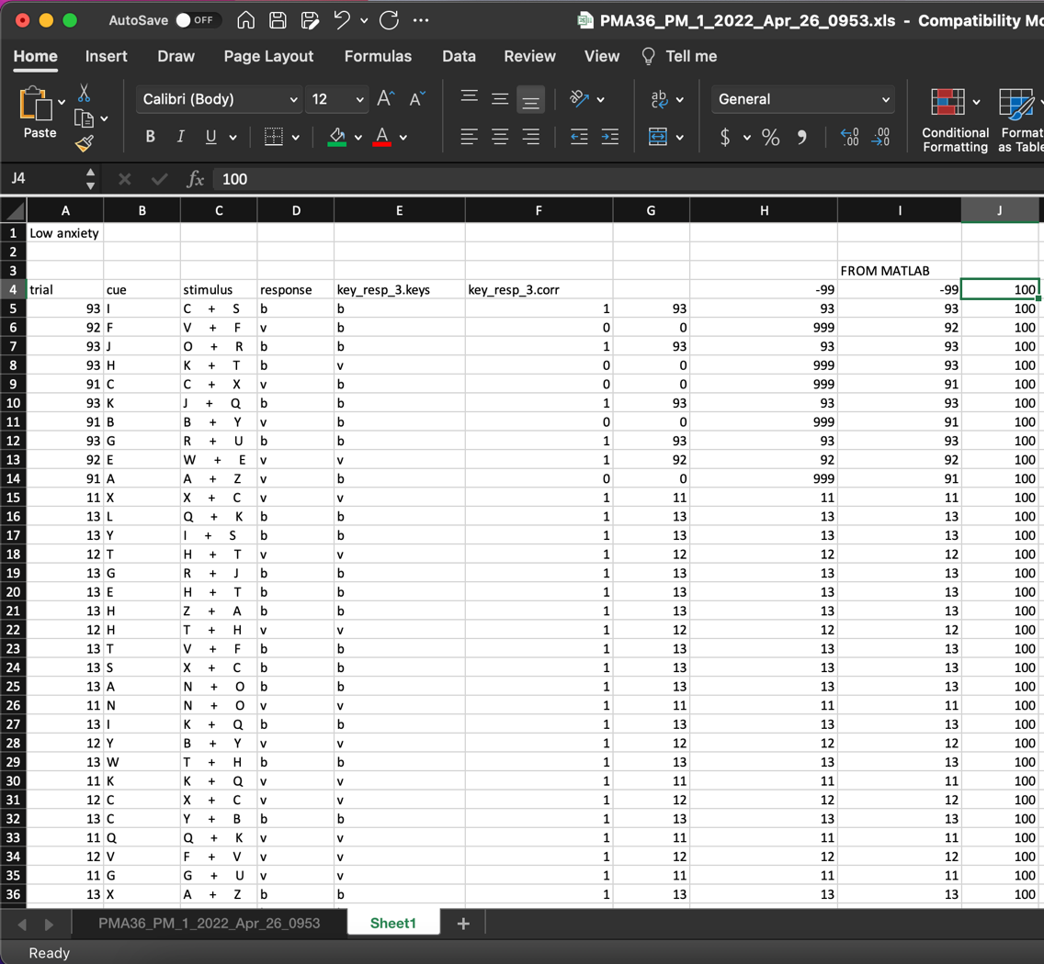

h. Next to the column of 100s, type =SUM(). In the parentheses, select the cell that is to the left of the “FROM MATLAB” column, and the corresponding cell that contains 100 (ex. =SUM(J4,H4) ).

Drag this cell down (using the small green box) so the formula fills every cell in the column.

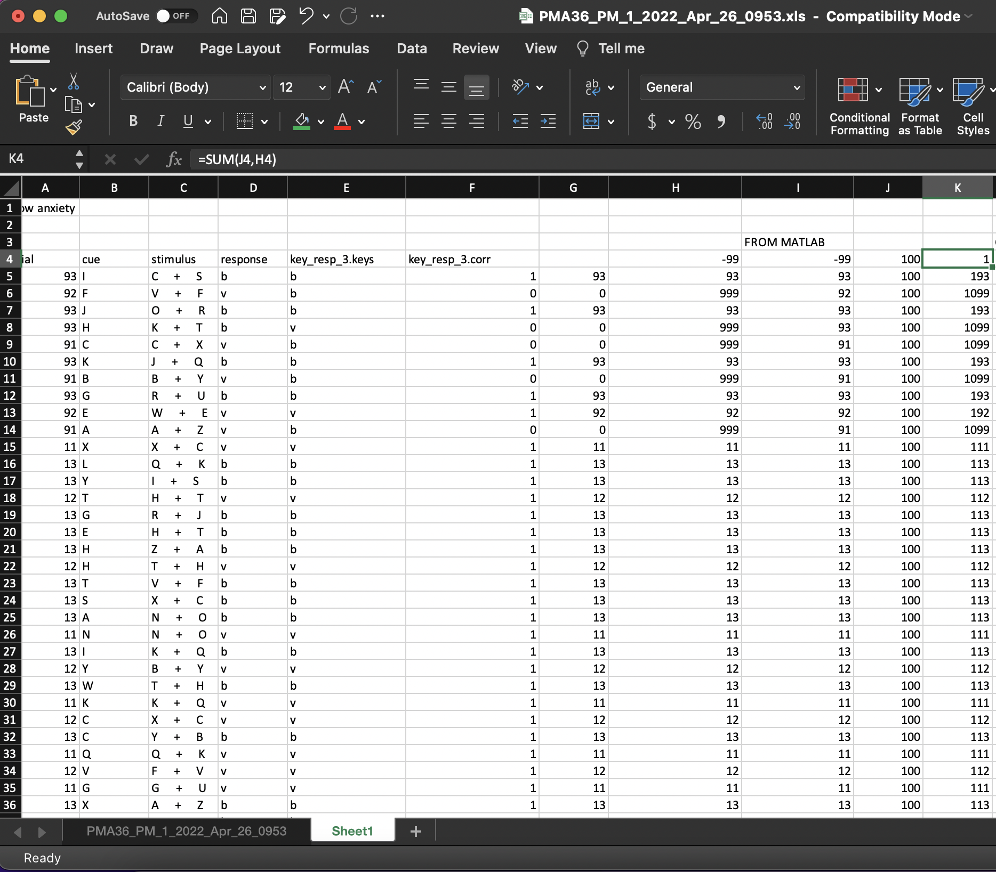

i. To the right of the column you have just made, type the following formula:

=IF(K4=1,-99,IF(K4=1099,999,K4)).

NOTE: You will likely need to change K4 to match the appropriate column and row. You want the first cell of the column you created in step h.

Drag this cell down (using the small green box) so the formula fills every cell in the column.

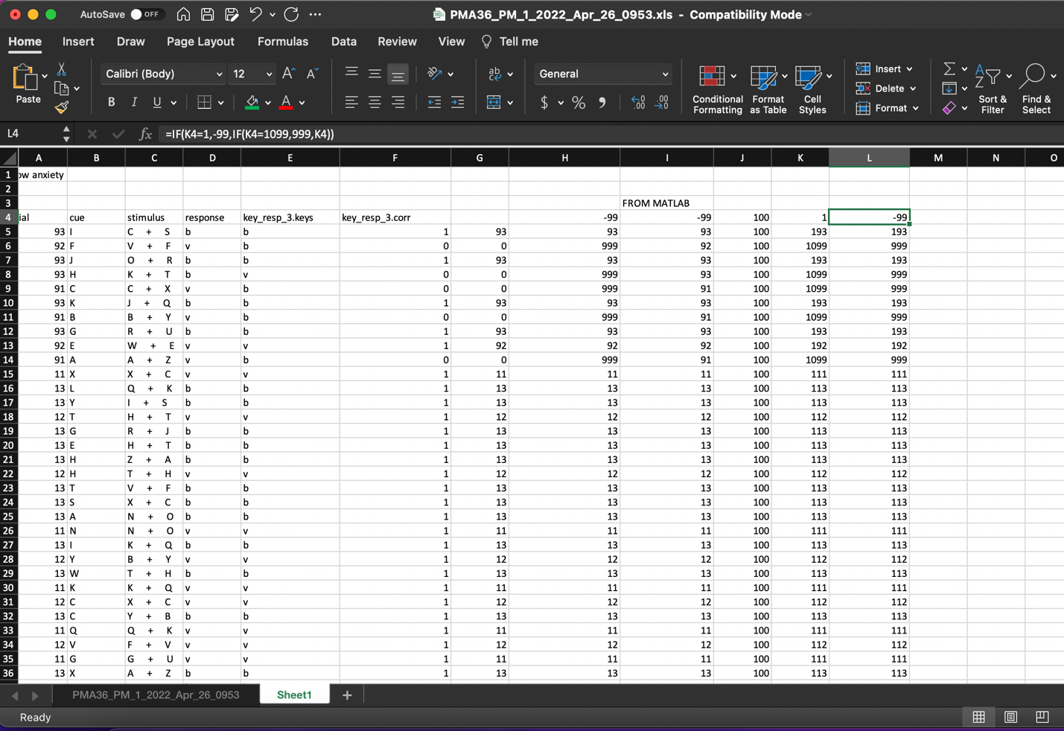

Title this new column “CORRECT CODES”

You are now done!

